**Picture Lab**

**A2: Picking a color**

Run the main method in ColorChooser.java. This will pop up a window (Figure 2) asking you to pick a color. Click on the RGB tab and move the sliders to make different colors.

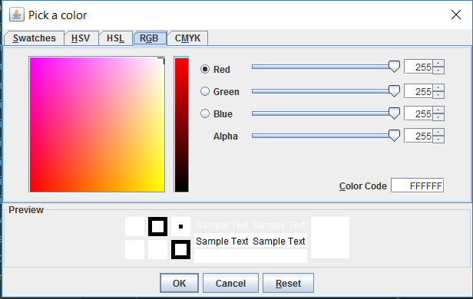

Figure 2: The Color Chooser

When you click the OK button, the red, green, and blue values for the color you picked will be displayed as shown below. The Color class has a toString method that displays the class name followed by the red, green, and blue values. The toString method is automatically called when you print an object.

**java.awt.Color[r=139,g=174,b=255]**

Picture class contains the following import statement.

**import java.awt.Color;**